**ML/CLOUD Project tasks description**

**Property Price Prediction in Tunisia**

By: Laawer Sameh & Sakka Mohamed Anis

Table of Content

Desired Architecture 3

Create S3 bucket 3

Create notebook in amazon SageMaker 4

Import libraries and dataset 4

Data Vis: 4

Data preprocessing / Build /Train/test/Save 4

Creating Github Repo for the Proejct 5

Creating and configuring the EC2 5

Hosting app in the EC2 steps 5

Final output 6

The aim of this white paper is to detail the different tasks donr during this project:

## Desired Architecture

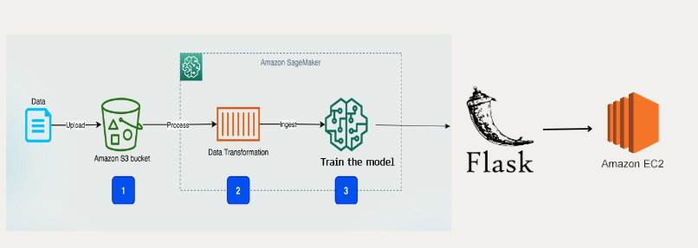

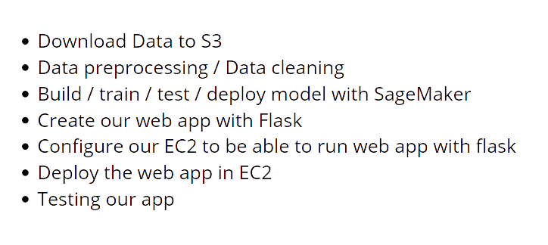

## Create S3 bucket

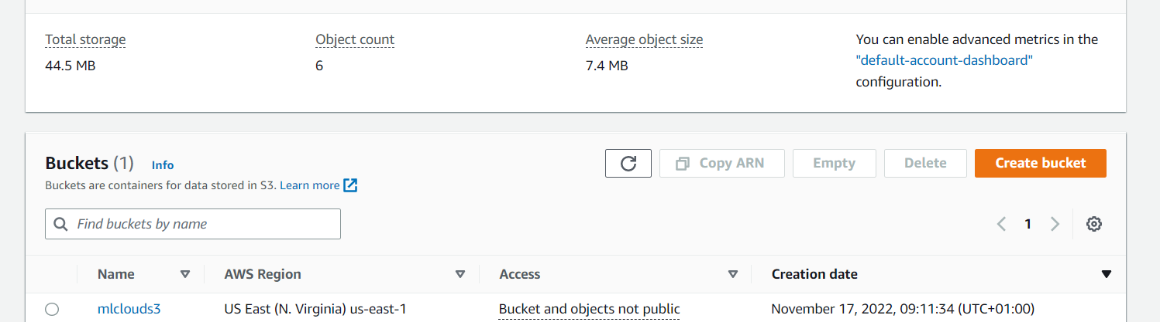

## Create notebook in amazon SageMaker

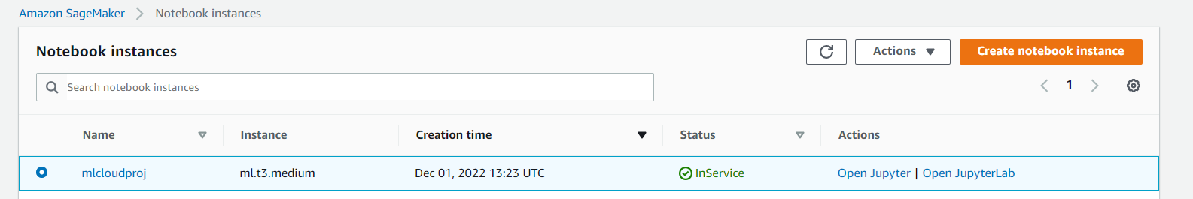

We faced some problemes with amazon sagemaker when deploying the model so we tried to create the model in local then push it to github and finally we the app in EC2 .

## Import libraries and dataset

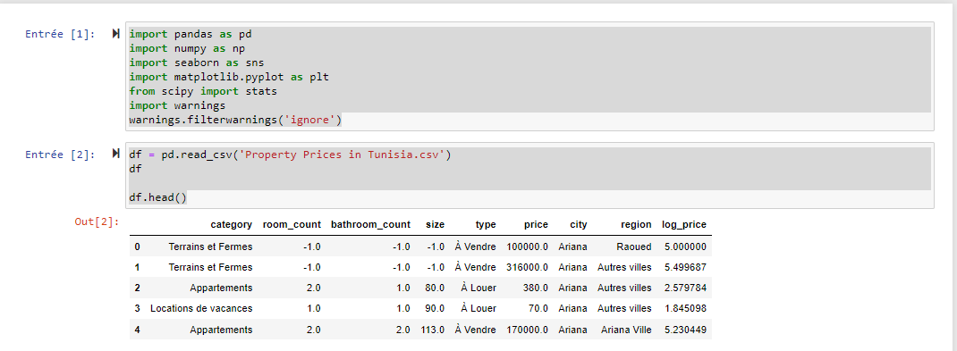

## Data Vis: double click below to see code and description



## Data preprocessing / Build /Train/test/Save model double click below to see code and description



## Creating Github Repo for the Proejct

## 

## Creating and configuring the EC2

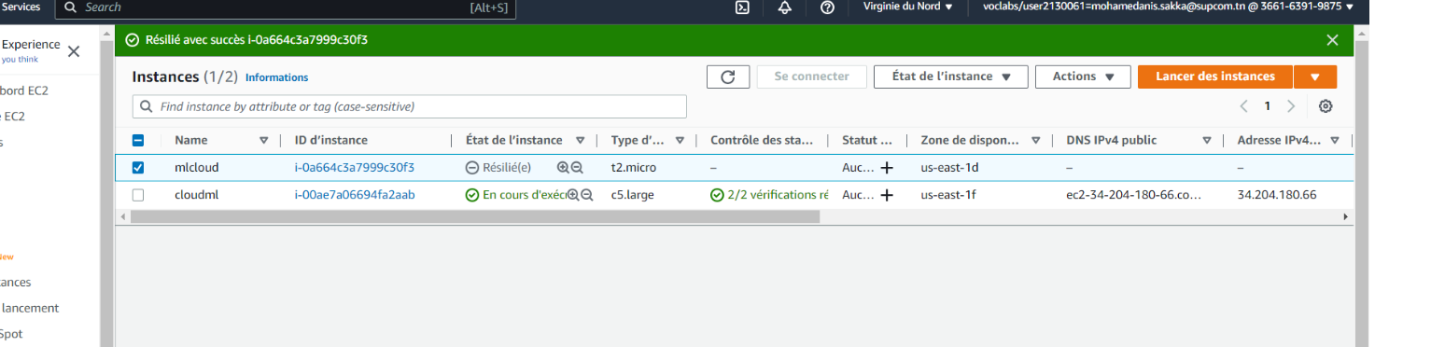

## Hosting app in the EC2 steps

* We clone the repo in the EC2
* Install Python Virtualenv
* Create and activate the virtual environment
* Install Flask
* Install required dependencies and libraries to run the app
* Install and Run Gunicorn WSGI server to serve the Flask Application When you “run” flaskAz:
* We create a .service to describe what would happen to gunicorn when the system reboots. The server will be running in the background of the instance automatically
* Then enable the service
* Run Nginx Webserver to accept and route request to Gunicorn Finally ( figure as the proxy of our app )

Github link for more details and code :

<https://github.com/yeshwanthlm/YouTube/blob/main/flask-on-aws-ec2.md>

## Final output

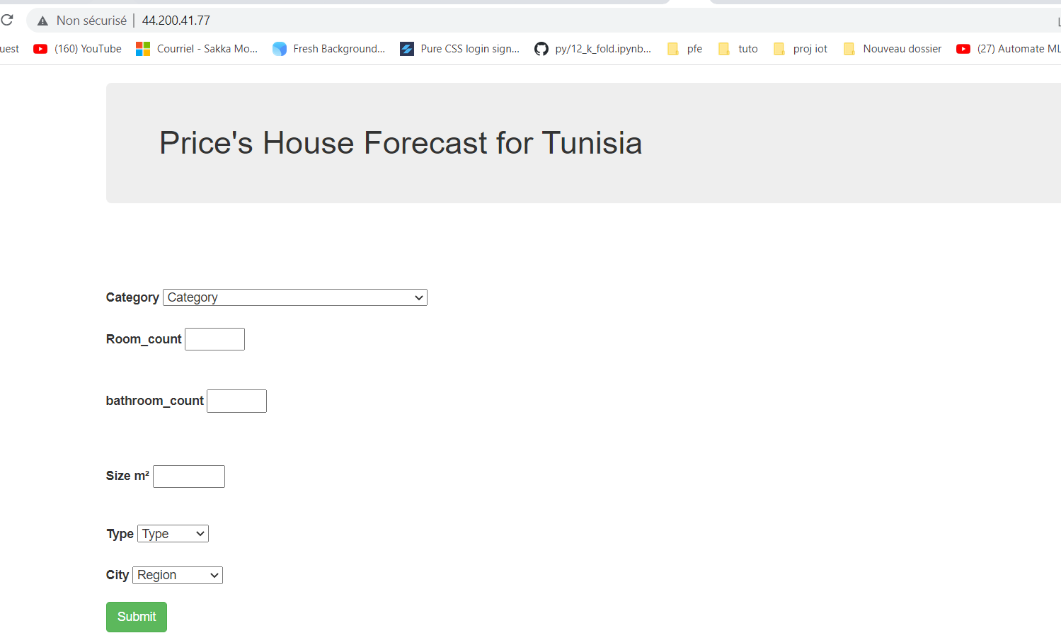

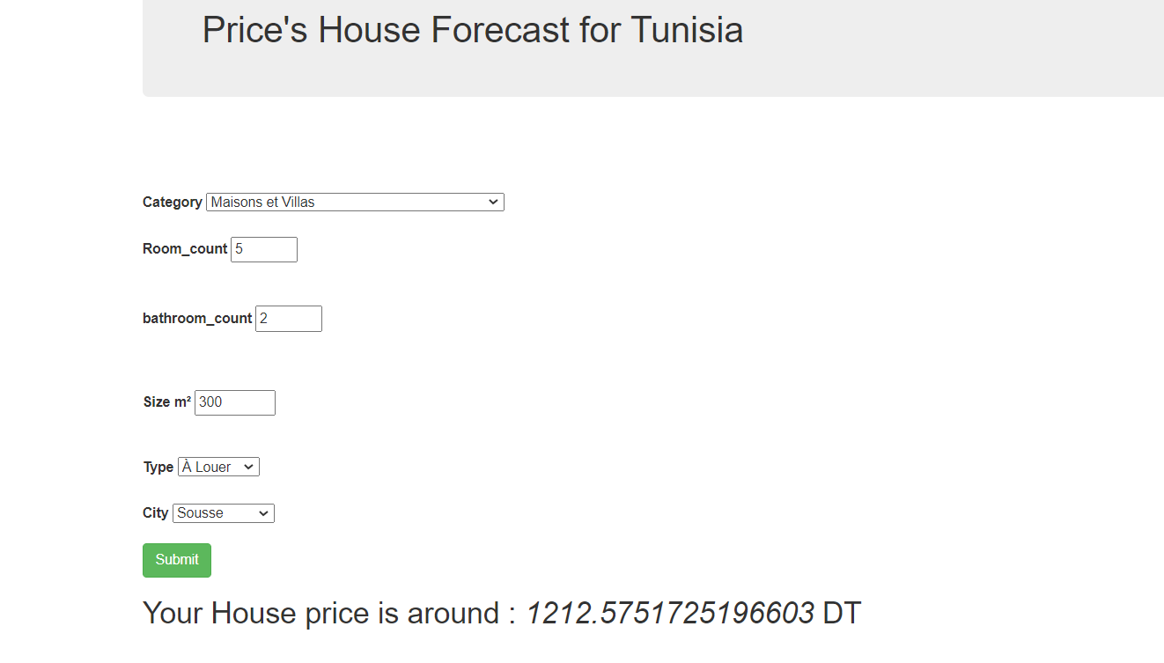

Github repo link : https://github.com/sakkovic/mlcloud

…